LAPORAN PRAKTIKUM PEMROGRAMAN WEBSITE I

MODUL 5



Disusun Oleh:

YOUNKY REZA AGP

2105101017

**PRODI TEKNIK INFORMATIKA FAKULTAS TEKNIK UNIVERSITAS PGRI MADIUN**

**2023/2024**

1. **Latihan Praktikum**

<!--PENGERTIAN TAG <form>-->

<form action="prosesdata.php" method="post">

</form>

<!--MENGENAL TAG <textarea-->

<textarea rows="5" cols="20">

Text yang diisi dapat mencapai banyak baris

</textarea>

<!--MENGENAL TAG < select>-->

<select>

<option>Pilihan 1</option>

<option>Pilihan 2</option>

<option value="pilihan ketiga">Pilihan 3</option>

</select>

<select>

<option>Pilihan 1</option>

<option>Pilihan 2</option>

<option value="pilihan ketiga" selected>Pilihan 3</option>

</select>

<!--MENGENAL ATRIBUT NAME-->

<input type="text" name="username">

<input type="text" name="email">

<hr align="left" size="5" color="pink">

<!--LATIHAN PRAKTIKUM-->

<!DOCTYPE html>

<html>

<head>

<title>Belajar Membuat Form </title>

</head>

<body>

<form action=" formulir.html" method="get">

Nama: <input type="text" name="nama" value="Nama Kamu" />

<br />

Password: <input type="password" name="password" />

<br />

Jenis Kelamin :

<input type="radio" name="jenis kelamin" value="laki-laki" checked /> Laki - Laki

<input type="radio" name="jenis kelamin" value="perempuan" /> Perempuan

<br />

Hobi: <input type="checkbox" name="hobi_baca" /> Membaca Buku

<input type="checkbox" name="hobi_nulis" checked /> Menulis

<input type="checkbox" name="hobi_mancing" /> Memancing

<br /> Asal Kota:

<select name="asal_kota" >

<option value="Kota Jakarta"> Jakarta</option>

<option>Bandung</option>

<option value="Kota Semarang" selected>Semarang</option>

</select>

<br /> Komentar Anda:

<textarea name="komentar" rows="5" cols="20"> Silahkan katakan isi hati anda

</textarea>

<br />

<input type="submit" value="Mulai Proses!" >

</form>

</body>

</html>

**Hasil running program:**

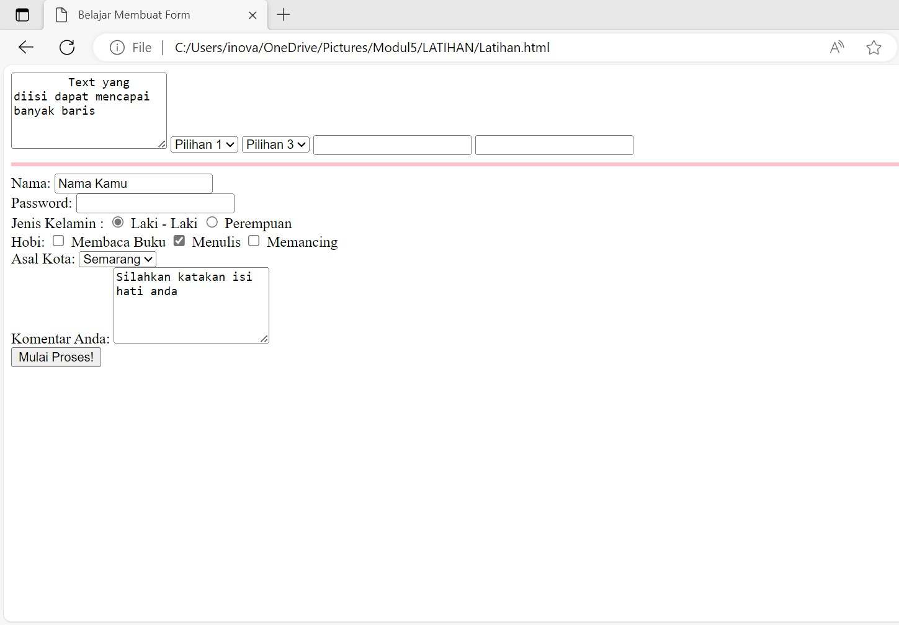

1. **Tugas Praktikum**
   1. **Memperbaiki source code praktikum**
   2. **Menyusun source code serapi mungkin**

<!DOCTYPE html>

<html lang="en">

<head>

<meta charset="UTF-8">

<meta name="viewport" content="width=device-width, initial-scale=1.0">

<title>Belajar Membuat Form</title>

<style>

body {

font-family: Arial, sans-serif; margin: 20px;

}

form {

max-width: 400px; margin: auto;

}

label {

display: block; margin-bottom: 5px;

}

input, select, textarea { margin-bottom: 10px;

}

</style>

</head>

<body>

<form action="formulir.html" method="get">

<label for="nama">Nama:</label>

<input type="text" name="nama" id="nama" value="Nama Kamu" />

<label for="password">Password:</label>

<input type="password" name="password" id="password" />

<label>Jenis Kelamin:</label>

<input type="radio" name="jenis_kelamin" value="laki-laki" id="laki- laki" checked />

<label for="laki-laki">Laki-laki</label>

<input type="radio" name="jenis_kelamin" value="perempuan" id="perempuan" />

<label for="perempuan">Perempuan</label>

<label>Hobi:</label>

<input type="checkbox" name="hobi_baca" id="hobi_baca" />

<label for="hobi_baca">Membaca Buku</label>

<input type="checkbox" name="hobi_nulis" id="hobi_nulis" checked />

<label for="hobi_nulis">Menulis</label>

<input type="checkbox" name="hobi_mancing" id="hobi_mancing" />

<label for="hobi_mancing">Memancing</label>

<label for="asal_kota">Asal Kota:</label>

<select name="asal_kota" id="asal_kota">

<option value="Kota Jakarta">Jakarta</option>

<option value="Bandung">Bandung</option>

<option value="Kota Semarang" selected>Semarang</option>

</select>

<label for="komentar">Komentar Anda:</label>

<textarea name="komentar" id="komentar" rows="5" cols="20">Silahkan Katakan Isi Hati Anda</textarea>

<input type="submit" value="Mulai Proses!">

</form>

</body>

</html>

**Hasil running adalah sebagai berikut:**

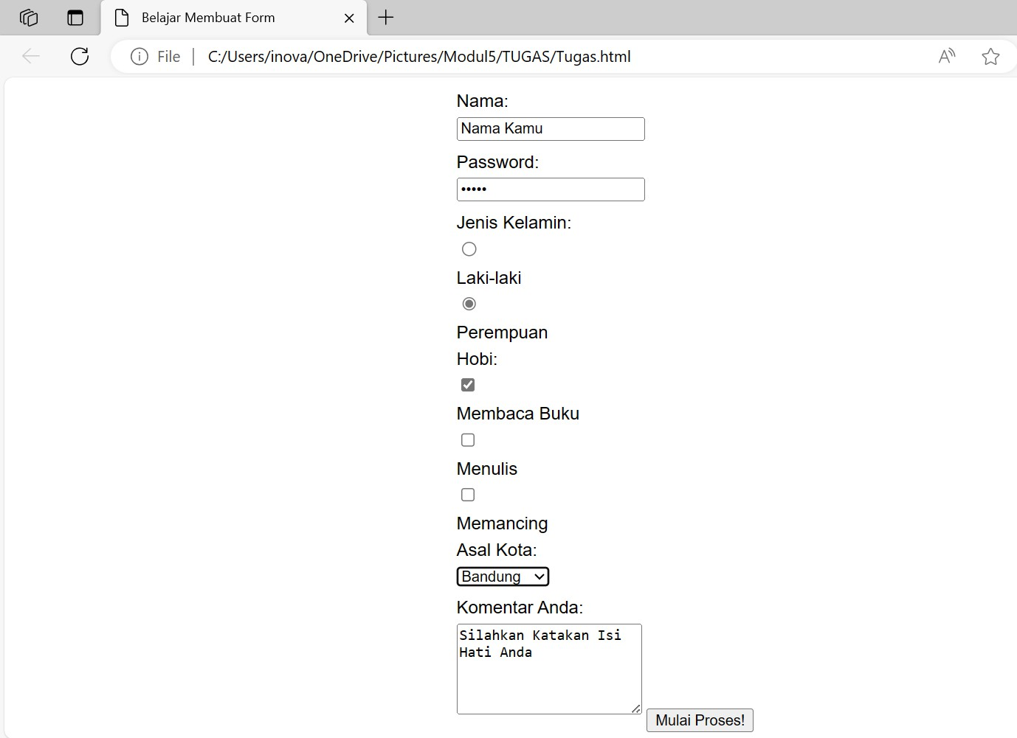

* 1. **Membuat halaman Formulir_Perpuskotamadiun.html**

<!DOCTYPE html>

<html lang="en">

<head>

<meta charset="UTF-8">

<meta name="viewport" content="width=device-width, initial-scale=1.0">

<style>

body {

font-family: Arial, sans-serif; margin: 20px;

}

h2 {

color: #333;

text-align: center;

}

form {

max-width: 400px; margin: auto;

}

label {

display: block; margin-bottom: 5px;

}

input, select, textarea { margin-bottom: 10px;

}

</style>

</head>

<body>

<h2>Formulir Perpustakaan Kota Madiun</h2>

<form action="proses_formulir.html" method="post">

<label for="nama">Nama :</label>

<input type="text" id="nama" name="nama" required>

<label for="alamat">Alamat :</label>

<input type="text" id="alamat" name="alamat" required>

<label for="email">Email :</label>

<input type="email" id="email" name="email" required>

<label for="telepon">Nomor Telepon :</label>

<input type="tel" id="telepon" name="telepon" required>

<label for="buku">Judul Buku yang Dipinjam :</label>

<input type="text" id="buku" name="buku" required>

<label for="durasi">Durasi Peminjaman (hari) :</label>

<input type="number" id="durasi" name="durasi" required>

<label for="catatan">Catatan :</label>

<textarea id="catatan" name="catatan" rows="4" cols="50"></textarea>

<label for="kategori">Kategori Buku :</label>

<select id="kategori" name="kategori">

<option value="fiksi">Fiksi</option>

<option value="non-fiksi">Non-Fiksi</option>

<option value="sejarah">Sejarah</option>

<option value="jurnal">Jurnal</option>

</select>

<button type="submit">Kirim Formulir</button>

</form>

</body>

</html>

**Hasil running program adalah sebagai berikut:**

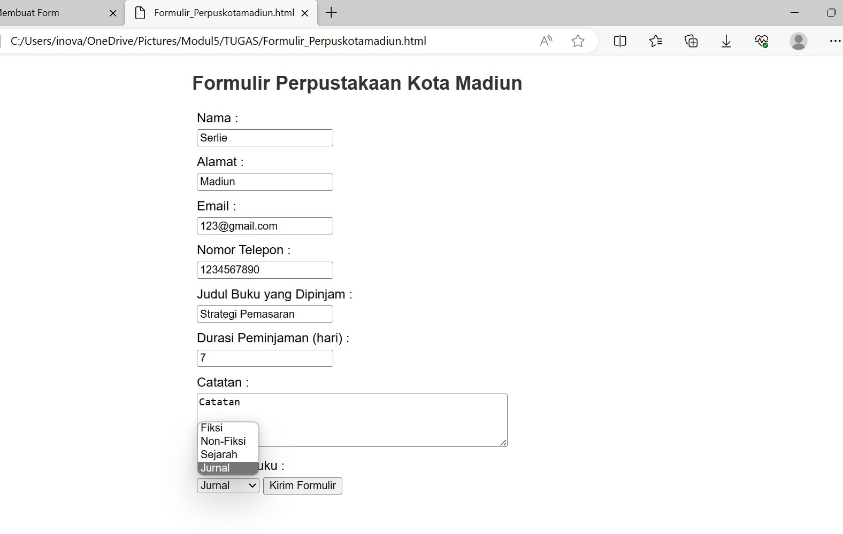

**c. Membuat halaman Formulir_kliniksehat.html**

<!DOCTYPE html>

<html lang="en">

<head>

<meta charset="UTF-8">

<meta name="viewport" content="width=device-width, initial-scale=1.0">

<style>

body{

font-family: Arial, sans-serif; margin: 20px;

}

h2{

}

color: #333;

text-align: center;

form{

max-width: 400px; margin: auto;

}

label{

display: block; margin-bottom: 5px;

}

input, select, textarea{ margin-bottom: 10px;

}

</style>

</head>

<body>

<h2>Formulir Klinik Sehat</h2>

<form action="Formulir_KlinikSehat.html" method="get">

<label for="nama">Nama :</label>

<input type="text" id="nama" name="nama" required>

<label for="alamat">Alamat :</label>

<input type="text" id="alamat" name="alamat" required>

<label for="email">Email :</label>

<input type="email" id="email" name="email" required>

<label for="telepon">Nomor Telepon :</label>

<input type="tel" id="telepon" name="telepon" required>

<label for="keluhan">Keluhan :</label>

<textarea id="keluhan" name="keluhan" rows="2" cols="50" required></textarea>

<label for="poli">Poli :</label>

<select id="poli" name="poli">

<option value="umum">Umum</option>

<option value="gigi">Gigi</option>

<option value="mata">Mata</option>

<option value="paru">Paru</option>

<option value="rehabilitasimedik">Rehabilitasi Medik</option>

<option value="penyakitdalam">Penyakit Dalam</option>

</select>

<button type="submit">Kirim Formulir</button>

</form>

</body>

</html>

**Hasil running program adalah sebagai berikut:**

